 |  | Put your translation in this column
 | That's how it works
 | Lüttje Lage
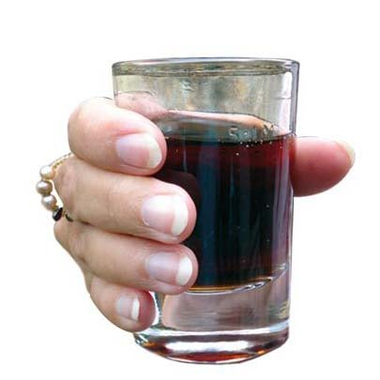 | When you pour the liquid do observe the measuring line. Do not pour too much liquid into the glasses (especially the Schnappsglass / Shotglass) otherwise you will spill the drink
 | Take the beer glass into your hand and put all fingers to the glass.
 | Leave about a finger width of space to the top of the glass.
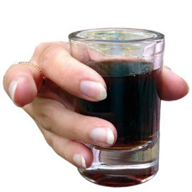 | (this will work no matter how big or small your fingers are)
 | Push the middle finger out.
 | (All other fingers remain attached to the glass).
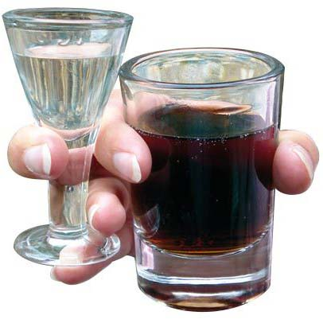 | Put the Schnappsglass between your middle finger and your ring finger.
 | The ring finger is between the two glasses and sits on top of the foot of the Schnappsglass.
 | Now adjust the Schnappsglass to be about 5 mm above the Beer glass.
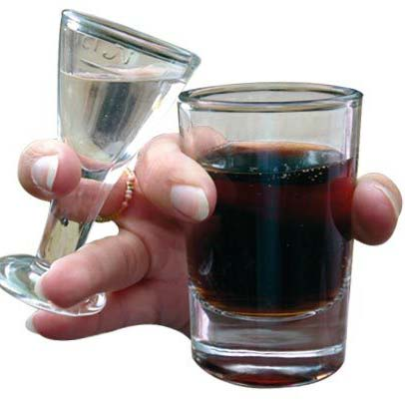 | Use your ring finger to push the stem of the Schnapps glass so that the top touches the Beer glass!
 | (Important: the two glasses must touch so that the Schnapps can flow from the Schnappsglass into the Beer glass)
 | Stand straight / Stand tall
 | (Important: do not lean forward in fear of spilling the drink)!
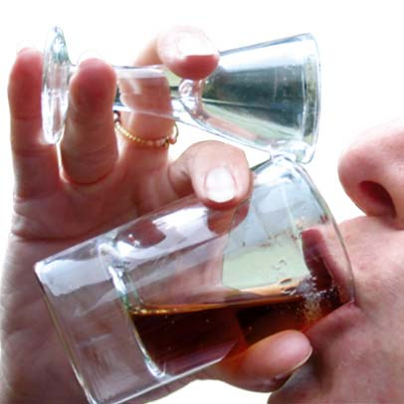 | - drink exactly opposite the Schnappsglass  allowing the Schnapps to flow directly into the beer glass
 | - everything in one go
 | - drink speedy, but not hastily!
 | - Head held high and when you drink look into the sky / to the ceiling.
 | Important: do not tilt the glasses (like drinking beer or wine) but knock your head back!
 | Cheers!
Watch this instruction in a video tutorial:
www.luettjelage.com/tutorial

 | LÜTTJE LAGE
 | The Hannover National drink
 | As a present and souvenir
Typical Hannover souvenir
in gift box
1 Lüttje Lage chocolate
1 Box Leibniz bisquits
1 Package Hannover coffee
2 x Glass sets
1 x 0,5 l Lüttje Lage beer 3%
1 x 0,1 l Schnapps 32%

Your Choice of Lüttje Lage Beer
Gilde, Hanöversch or Herrenhäuser

Couples Set for two
in gift box
2 x Glass sets
1 x 0,5 l Lüttje Lage beer 3%
1 x 0,1 l Schnapps 32%

Lüttje Lage Chocolate

Chocolate meets beer and schnapps

Award GOLD and SILVER by the
International Chocolate Awards as
„best filled chocolate in Germany,
Austria and Switzerland“
Milk- or Dark Chocolate, 100 g
 | Subject to change
 | Das Hannover Geschenk
 | Hier kaufen
Lüttje Lage Instruction in _(your Language)_
(text for internet page i.e.:
Lüttje lage instructions in chinese)
 | Download the printable instructions here
 | Click here for more languages
Information for you (not to be translated):

Please send this instruction to:
info@luettje-lage.de

This instructions together with
corresponding pictures click:
http://www.luettjelage.com/tutorial

